vim livenessprobe.yaml

apiVersion: v1

kind: Pod

metadata:

name: liveness

spec:

containers:

- name: liveness

image: ubuntu

tty: true

livenessProbe:

exec:

command:

- service

- nginx

- status

initialDelaySeconds: 20

periodSeconds: 5

kubectl create -f livenessprobe.yaml

kubectl get pods

Notice container running

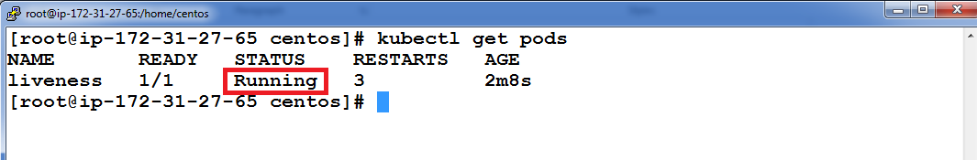

Again run kubectl get pods notice the container is not ready as it does not meet the command requirement in yaml which looks for service nginx status which is not installed on Ubuntu image container keeps on restarting until service nginx status shows success message

